COURSE INFORMATION SHEET
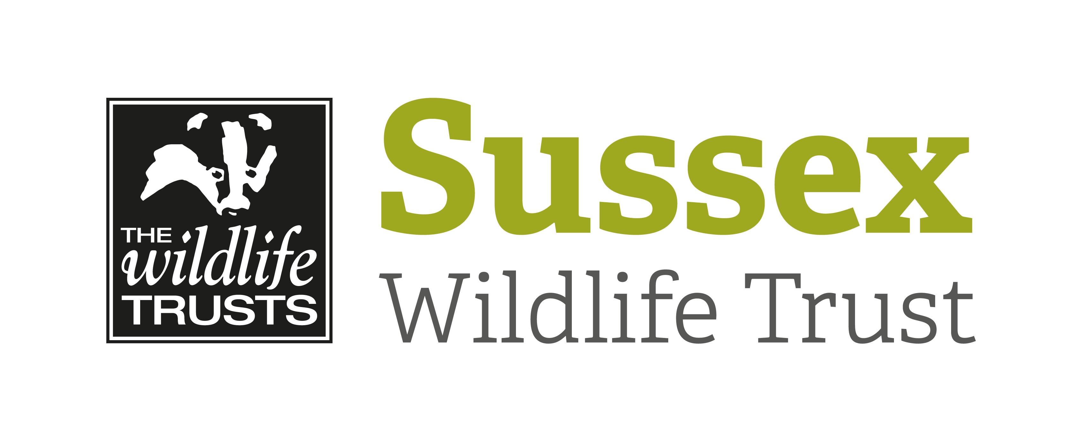

Course Title: An Evening with Glow Worms |  |  | Day/Date/Year:  Friday 3 July 2020
Start Time: 8pm |  | Finish Time: 11pm
Course Tutor: | Michael Blencowe
Course description and subjects covered | An encounter with a glow worm is a unique and magical experience. During this event you’ll learn all about these incredible little insects and then head out on a night-time ramble looking for glow-worms (as well as Nightingales, owls and other nocturnal wildlife).  We’ll start the evening indoors at Woods Mill with an illustrated presentation all about these enigmatic insects. Learn all about their lives and their place in folklore and literature. Then as the sun sets we’ll head out to search for glow worms in the surrounding countryside.  No previous knowledge required.  Classroom and outdoor sessions.
Meeting point/Venue address & nearest post code | Meet in The Mill at Woods Mill, Henfield, West Sussex, BN5 9SD
Other sites to be visited: | Woods Mill nature reserve and surrounding countryside. Walk of approx. 2.5 km.
What to bring: | Warm clothes, sturdy footwear, binoculars and a torch.
Other Information: | Coffee / tea supplied.  Toilet facilities.
Public Transport:

Accessibility: | The walk is approx. 2.5 km on public footpaths. There are no slopes but there is 1 stile to negotiate.

