COURSE INFORMATION SHEET
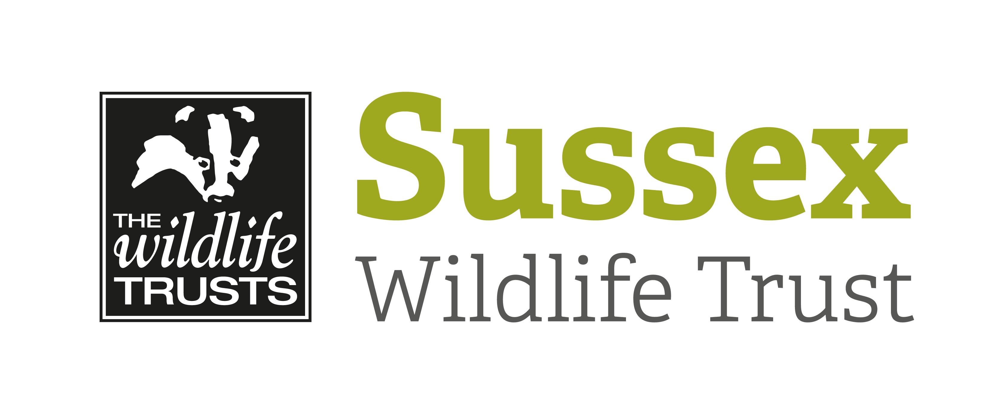

Course Title: An Introduction to Moths and Moth Trapping |  |  | Day/Date/Year:  Saturday 4 July 2020
Start Time: 7pm |  | Finish Time: 11pm
Course Tutor: | Michael Blencowe
Course description and subjects covered | Some of the most amazing animals in Britain are flying at night but we rarely see them. This course gives you the opportunity to come face to face with the beautiful (and weird!) moths of Sussex and learn all about them.  The evening starts with an illustrated presentation that introduces you to the diversity of moth species that can be found in Sussex. Then we will open the previous night’s moth trap and study and identify what we have caught. Using field guides (provided but please bring any you have) you’ll get to grips with moth identification.  After these moths have been released we will set up moth traps out on the reserve to give us the chance to understand more about moth surveying and observe the moths as they come to the light.  Throughout the evening you will be provided with information about the moths of Sussex, how to identify them and what books and equipment are required to start moth surveying at home.  No previous knowledge required.  Classroom and field sessions.
Meeting point/Venue address & nearest post code | Meet in The Mill at Woods Mill, Henfield, West Sussex, BN5 9SD
Other sites to be visited: | Woods Mill nature reserve
What to bring: | Warm clothes, sturdy footwear and a torch.  Bring identification books if you have them but some books will be provided for use.
Other Information: | Coffee / tea supplied.  Toilet facilities.
Public Transport:

Accessibility: | Disabled access for indoor and outdoor session.

