COURSE INFORMATION SHEET
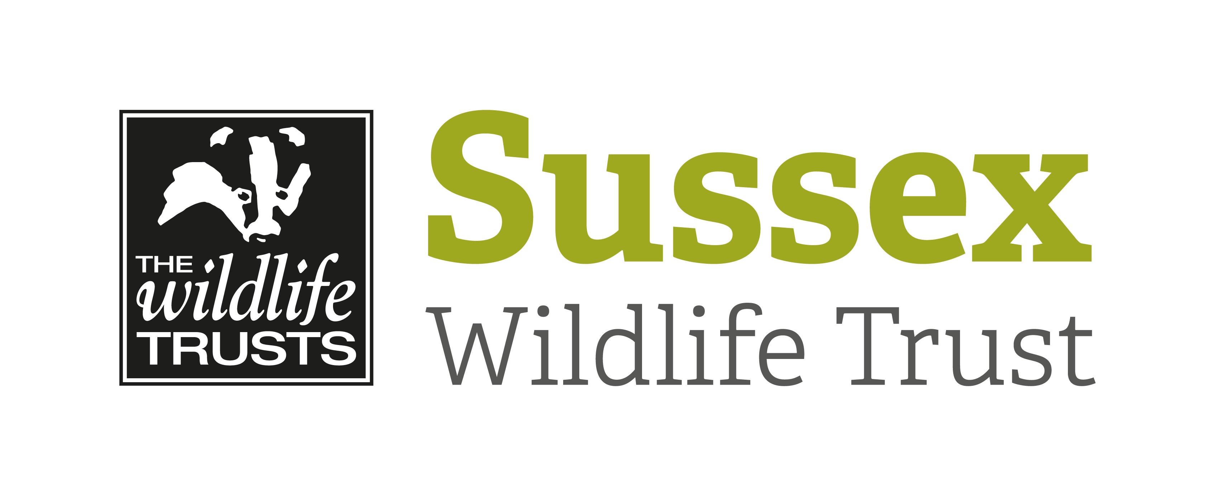

Course Title: Fieldcraft and Animal Tracking: Get Closer to Wildlife |  |  | Day/Date/Year  Saturday 9 May 2020
Start Time: 10am |  | Finish Time: 4pm
Course Tutor: | David Plummer
Course description and subjects covered | Renowned wildlife photographer and author David Plummer shares his secrets in this new course aimed at teaching you the field craft required to get closer to wildlife while respecting and not disturbing the wildlife itself.  Learn valuable tips about:  Tracking and stalking animals.  Animal’s tracks and signs in the field.  Using bird’s alarm calls to locate predators.  Camouflage, clothing and hides  ..and much more.  The course will be a combination of work in the classroom as well as out on the reserve at Woods Mill. Useful for wildlife photographers or those who just want to quietly observe British animals at close quarters.  Not suitable for children aged 14 and under
Meeting point / Venue address: | Classroom, Woods Mill. BN5 9SD
Other sites to be visited: | Woods Mill
What to bring: | Wear suitable clothing and footwear for the weather conditions.
Other Information: | Tea & coffee provided  Please may we ask that you take all packed lunch waste home with you.
Public Transport: | Compass Bus 100 Burgess Hill-Pulborough stops outside Woods Mill Monday – Saturday. No Sunday Service. Visit  http://www.compass-travel.co.uk for timetable.
Accessibility: | Easy walking. Can be muddy after rain.

