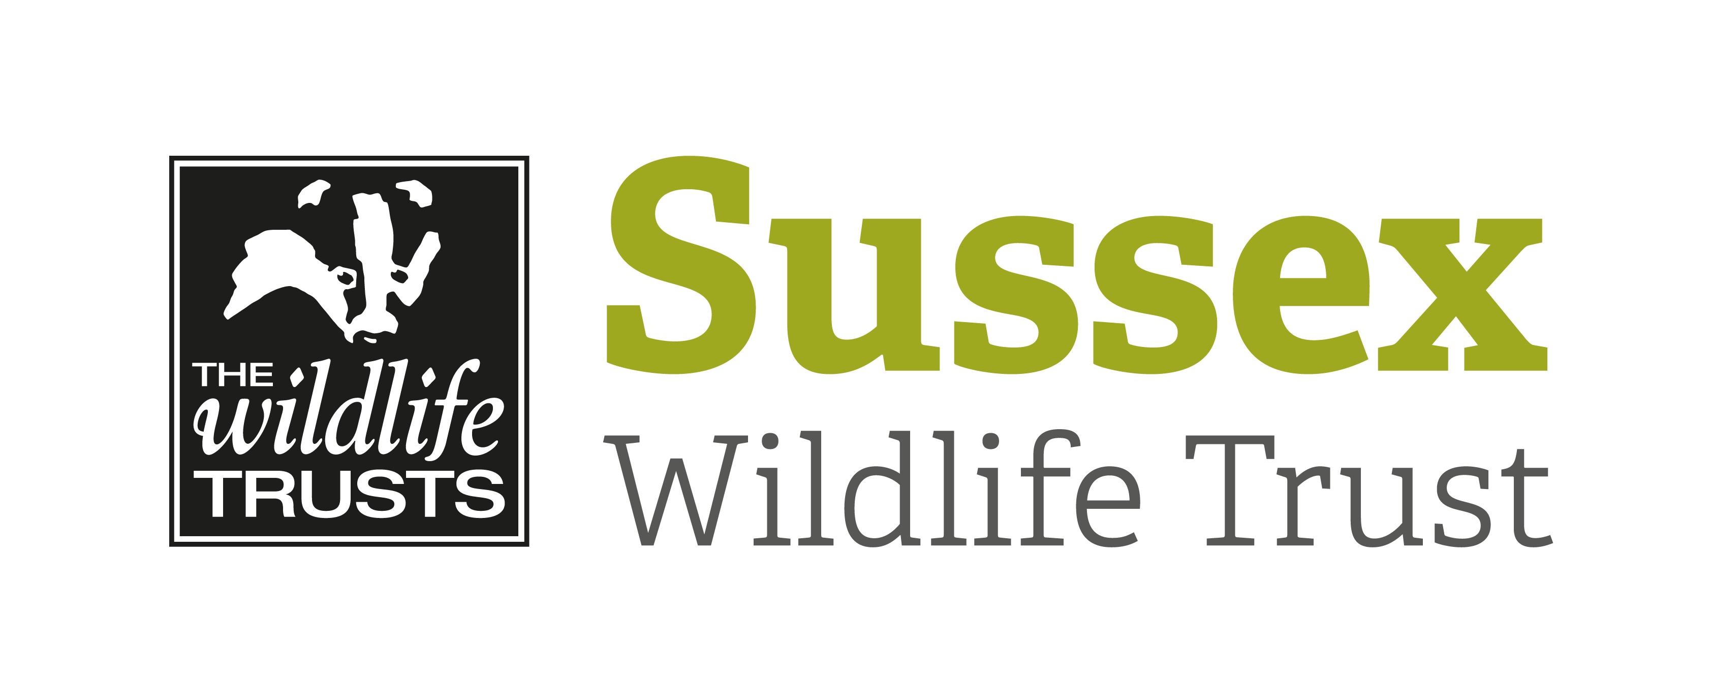
COURSE INFORMATION SHEET

Course Title: The Owls of Sussex |  |  | Day/Date/Year:  Wednesday 11 September 2019
Start Time: 3.30pm |  | Finish Time: 8pm
Course Tutor: | David Plummer
Course description and subjects covered | We will start the course with an illustrated talk about the owls of Sussex. Find out how these incredible birds have adapted as masters of nocturnal hunting. Learn about their ecology, diets, behaviour and how to identify them by sight and by call. In the evening we’ll head out to try to find our local owls. We’ll look and listen out for Tawny, Barn and Little Owls as the sun sets.
Meeting point / Venue address: | Classroom, Woods Mill, Henfield, West Sussex, BN5 9SD.
Other sites to be visited: | Woods Mill nature reserve and possibly another site nearby.
What to bring: | Packed Dinner  Binoculars  Suitable outdoor clothing and walking boots/wellingtons. We will be out at night so it will get cold.  Torch
Other Information: . | Tea & Coffee provided  Toilets on site  There will be a break to eat your meal
Public Transport: | No public transport in the evening.
Accessibility: | Woodland terrain. Can be muddy after rain.

