COURSE INFORMATION SHEET FOR WEBSITE
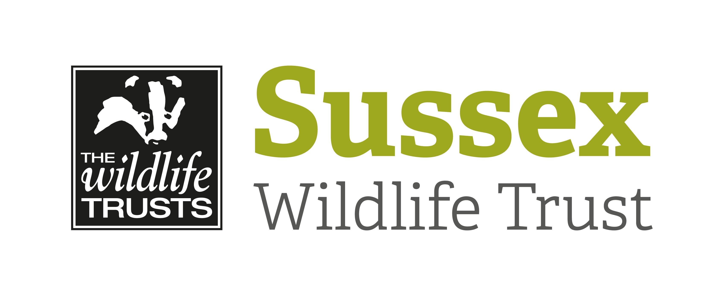

Course Title: Sussex Half-Day Bird Safari – Pevensey Levels |  |  | Day/Date/Year:  Tuesday 15 October 2019
Start Time: 9.30am |  | Finish Time: 1pm
Course Tutor: | Mike Russell
Course description and subjects covered | A walk that takes in a small part of Pevensey Levels at a time when the last of the summer migrants are moving out and the first of the winter migrants might be coming in. The walk takes in some wetlands, including walking along one of the dykes, farmland and hedgerows.  No previous knowledge or skills required, just enthusiasm!
Meeting point / Venue address: | We will meet in the public car park next to Pevensey Castle which is on the B2191 and is signposted off the A27 roundabout by the BP Service Station. The postcode for the Castle is BN24 5LE.  Pay & Display parking fees apply.  Google Map Link: https://goo.gl/maps/NW8Y2vmKGD6Ua9rx5
Other sites to be visited: | N/A
What to bring: | - Suitable clothing and footwear for being outside  - Drinks and refreshments for the morning  - Binoculars and a telescope if you have one  - A Field guide might be useful though leader will have one available
Other Information: | There are public toilets in the car park
Public Transport: | Contact Traveline for bus services at www.travelinesoutheast.org.uk
Accessibility: | It is flat walking on uneven ground that may be muddy after rain. There are some stiles  We will be walking for 3-4 miles.

