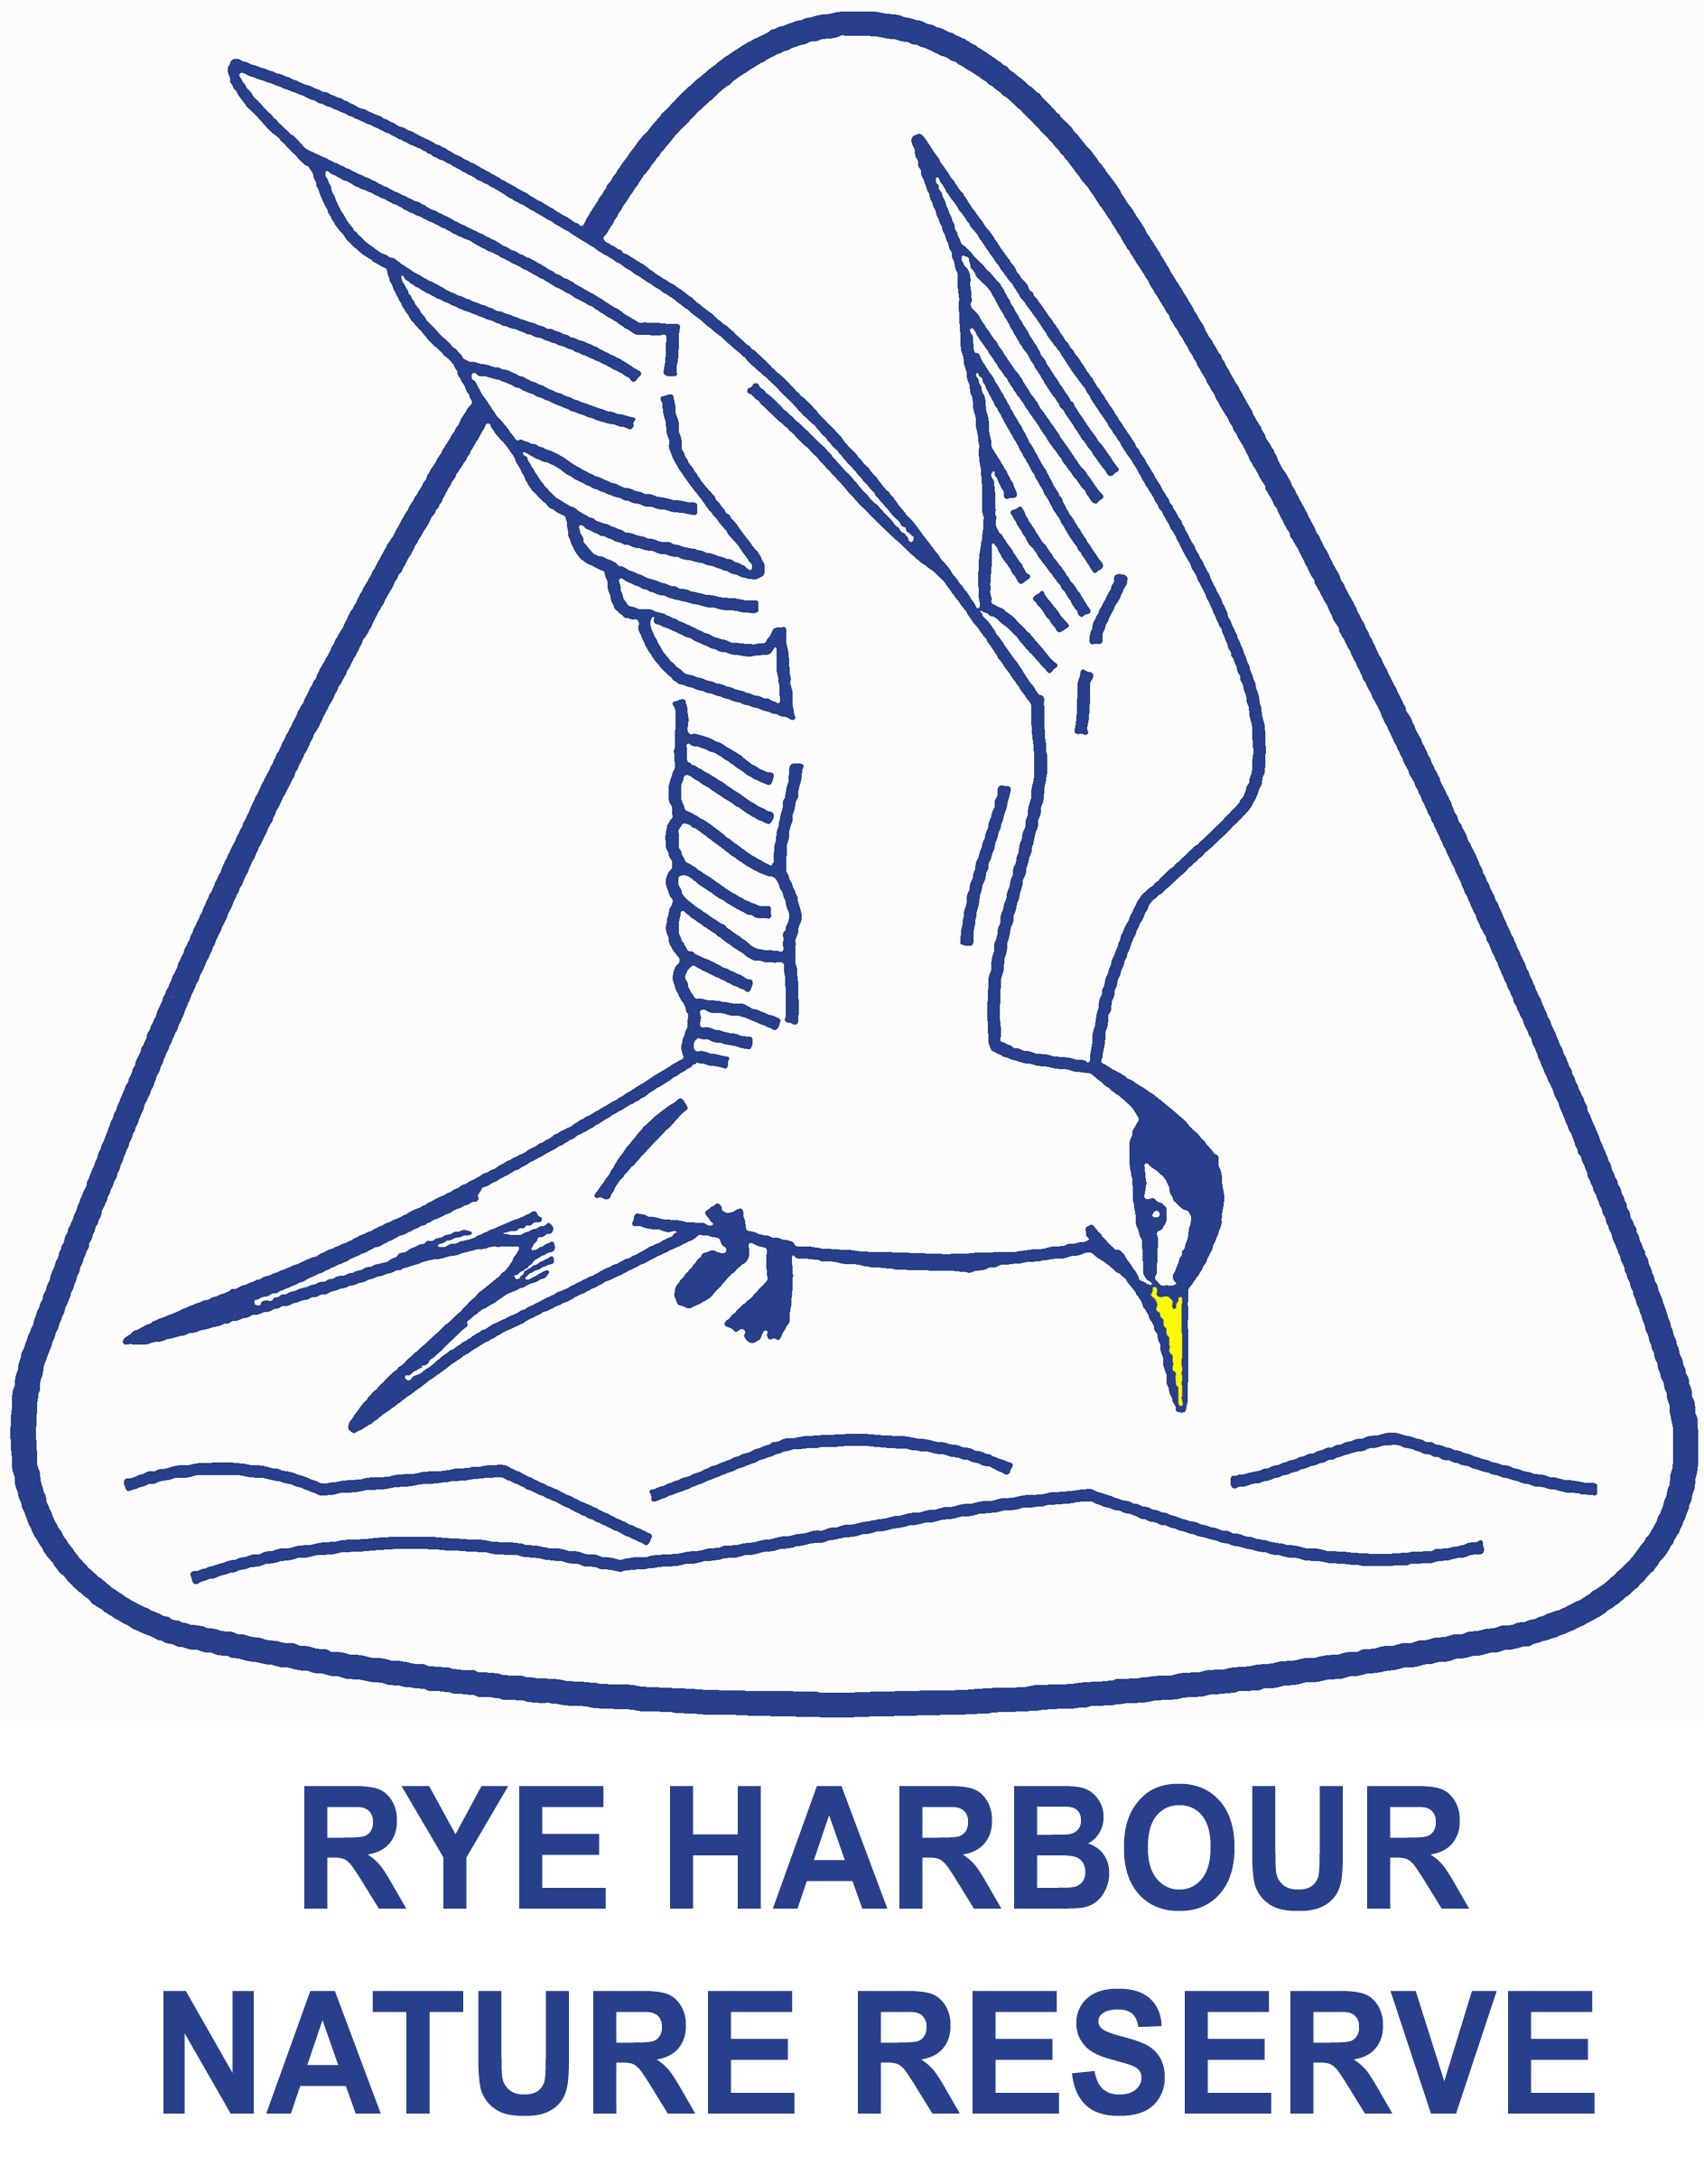
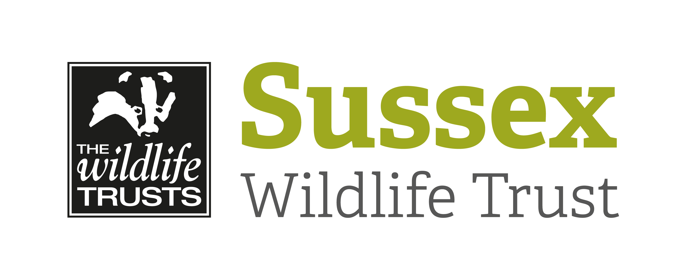
EDUCATIONAL VISIT BOOKING FORM

Thank you for your interest in a school visit to Rye Harbour Nature Reserve.

Please fill in the details below and return to us.

The school will be invoiced after your visit.

Please complete a separate booking form for each class visiting the nature reserve.

Name of School..........................................................................................................................

Address ...................................................................................................................................

...................................................................................Postcode .................................
Telephone number …….............................................................................................................

Name of visit organiser ………………................................................................................…….

Date of visit ……................ Time of arrival….................... Time of departure……….............

Has your school visited before? Yes / No
A pre-visit is recommended if you have not brought a group to the nature reserve before.

Number of pupils (maximum 35) .................. Age range of pupils...........……………...............

Number of accompanying adults................…
Please check with your LEA for recommended ratios.

Are there any special needs requirements which our staff should be aware of?....…………….

……………………………………………………………………………………………………………

What programme of study would you like to follow?
Please see our website for further details of programmes on offer

.................................................................................................................................................................................

.................................................................................................................................................................................

What are your learning outcomes for the visit? .........................................................................

...................................................................................................................................................

...................................................................................................................................................

We have a small gift shop onsite, would you like this to be open for your pupils? Yes / No

First Aid, discipline and lunchtime supervision are the responsibility of the school.

Signed................................................................ Print ...............................................................

Date ..................................

Please return this form to: Rye Harbour Nature Reserve, Lime Kiln Cottage, Harbour Road, Rye, East Sussex, TN31 7TU. Email: RHNRoffice@sussexwt.org.uk

